Copyright for test papers and marking guides remains with West Australian Test Papers.
They may only be reproduced within the purchasing school according to the advertised Conditions of Sale.
Test papers should be withdrawn after use and stored securely in the school until Friday 5th December 2014.



PHYSICS

YEAR 11

2A/2B

2014

Name:_______________________________

TIME allowed for this paper:
Reading time before commencing work 10 minutes
Working time for paper 3 hours

STRUCTURE OF THE PAPER

Section | No. of  Questions | No. of questions  to be attempted | Suggested working time  (minutes) | Marks available | Proportion of  exam total
1: Short Answers | 16 | ALL | 70 | 64 | 40%
2: Problem Solving | 8 | ALL | 90 | 80 | 50%
3: Comprehension and  Interpretation | 1 | ALL | 20 | 16 | 10%

Note: Above refers to 3 hour paper.

INSTRUCTIONS TO CANDIDATES

Write your answers in the spaces provided beneath each question. The value of each question (out of 160) is shown following each question.

The enclosed Physics: Formulae and Constants Sheet may be removed from the booklet and used as required.

Calculators satisfying conditions set by the School Curriculum and Standards Authority may be used to evaluate numerical answers. The calculator cannot be a “graphics” calculator.

Answers to questions involving calculations should be evaluated and given in decimal form. Final answers should be given up to three significant figures and include appropriate units where appropriate. Despite an incorrect final result, credit may be obtained for method and working, providing these are clearly and legibly set out.

Questions containing specific instructions to show working should be answered with a complete, logical, clear sequence of reasoning showing how the final answer was arrived at; correct answers which do not show working will not be awarded full marks.

Questions containing the instruction "ESTIMATE" may give insufficient numerical data for their solution. Students should provide appropriate figures to enable an approximate solution to be obtained.

Section 1: Short Answers

Marks allocated: 64 marks out of a total of 160 (40%)
Suggested working time: 70 minutes

Attempt ALL questions in this section. Not all questions attract the same marks.

Answers are to be written in the space below or next to each question.

Question 1 (2 marks)

An announcer on a radio station plays a practical joke on his listeners by announcing; ‘The temperature today will reach a maximum of 40 Kelvin. It will therefore be a great day to cool off at the beach’. Explain why the statement is not correct.

Question 2 (2 marks)

A bath towel containing 5.00 x 10 ² mL of water at 20 ºC is placed in the sun to dry. Calculate the quantity of heat required to evaporate all the water from the towel.

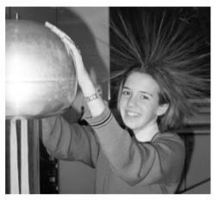
Question 3 (3 marks)

The photo opposite shows a girl standing on an insulated mat and holding on to a Van de Graaf generator that is supplying a very large electrical charge to her body. Explain why her hair is the way it is.

Question 4 (2 marks)

A student clamps two identical thermometers in retort stands next to each other. The bulb of one thermometer is wrapped in cotton wool soaked in methylated spirit and the other thermometer bulb is left uncovered. After a few minutes the student observes that the temperature readings on the thermometers differ by several degrees. Explain in terms of the kinetic theory the difference in temperatures.

Question 5 (5 marks)

A ride at Adventure World involves a roller coaster being hauled to a point 30.0 m above ground level (point A) and allowed to run down a series of slopes until it finally reaches ground level. The fully laden coaster has a mass of 6.00 tonnes.
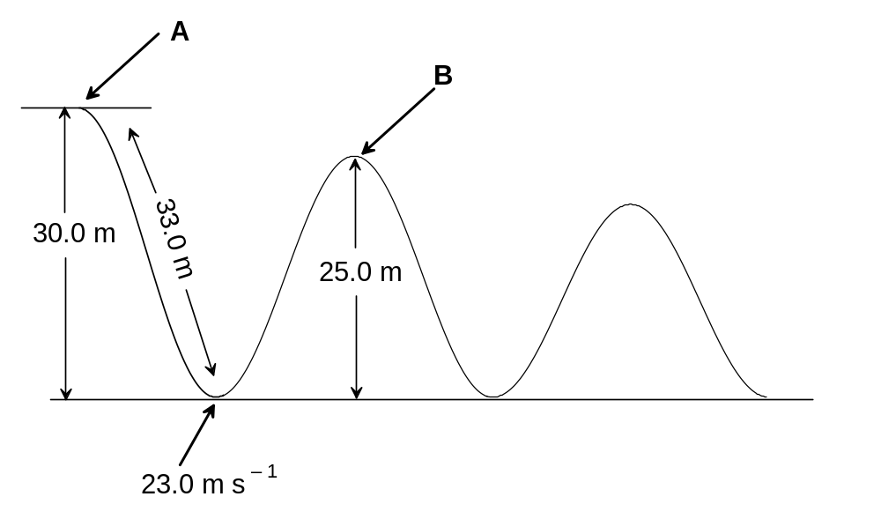
``(a) The fully laden coaster accelerates from rest down the first slope and reaches a velocity of 23.0 m s⁻¹ at the bottom. If the length of the slope is 33.0 m, calculate the acceleration it experiences running down the slope. (2 marks)

(b) If the roller-coaster is moving horizontally at a velocity of 5.00 km h⁻¹ when it just passes over the second slope (point B), calculate the percentage loss of energy due to friction and other factors. (3 marks)

Question 6 (3 marks)

A tree lopper cuts a 120.0 kg branch from a tree and it falls 5.00 m to the ground. Assuming the branch is in free fall, calculate:

(a) the speed of the branch when it hit the ground. (2 marks)

(b) the magnitude of the average force exerted on the ground during the impact if the impact time of the branch hitting the ground was 0.300 seconds. (1 mark)

Question 7 (4 marks)

The cathode ray tube in a television set accelerates electrons from rest through a potential difference of 85.0 kV.

(a) How much energy, in joules, does each electron gain in being accelerated in this
field? (2 marks)

- If the energy gained by each electron is 98% kinetic, calculate the velocity the
electron will have after undergoing this acceleration? (2 marks)

Question 8 (4 marks)

Warming up and cooling down exercises are very important not only for athletes, but for all people to get the most out of their muscles. Being able to warm up and cool down gradually allows the body to avoid sudden shocks and minimises the chance of injury.

- Suggest a strategy that a sportswoman, with an understanding of physics, could
apply to “cool down” after a hard game on a hot day. Explain the physics involved in
the strategy. (2 marks)

(b) Conversely, suggest a strategy for “warming up” before a game on a cold day, explaining the physics involved in the strategy. (2 marks)

Question 9 (6 marks)


A portable charger can be used to recharge a laptop computer when it is not convenient to connect it to the mains. A typical portable charger can deliver 18.0 V with a current of 2.50 A.

(a) If the device is connected to the laptop for 3.00 hours, how
much charge flows from the charger to the laptop in that
time? (2 marks)

(b) How many electrons are required to produce the charge calculated in (a) above? (2 marks)

(c) How much work is done in moving the charge? (2 marks)

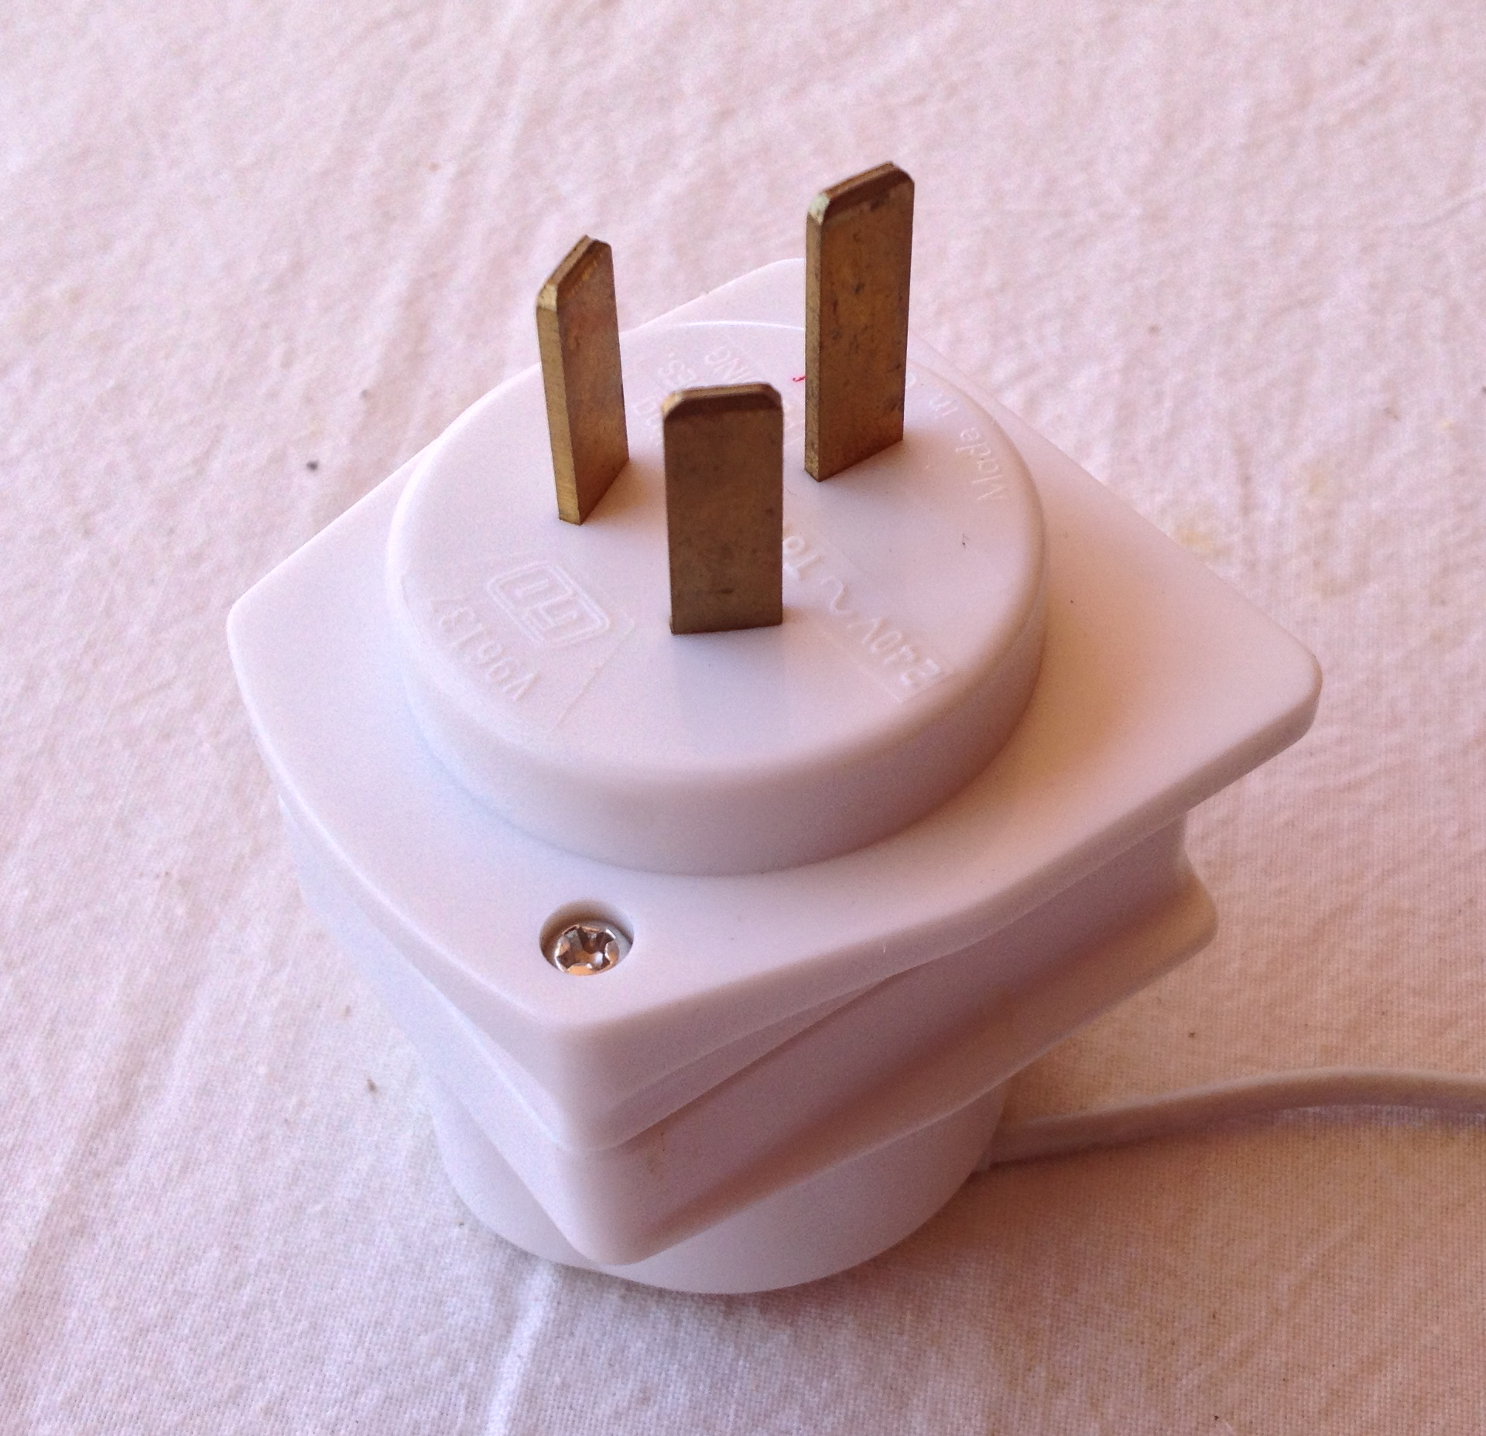
Question 10 (4 marks)
- Many household electrical appliances are connected to the mains with a cord and ‘3 pin’ plug. One of the pins on the plug is called the ‘earth’. Explain how the ‘earth pin’ helps to prevent users of the appliance from receiving an electric shock if the appliance malfunctions.

(2 marks)

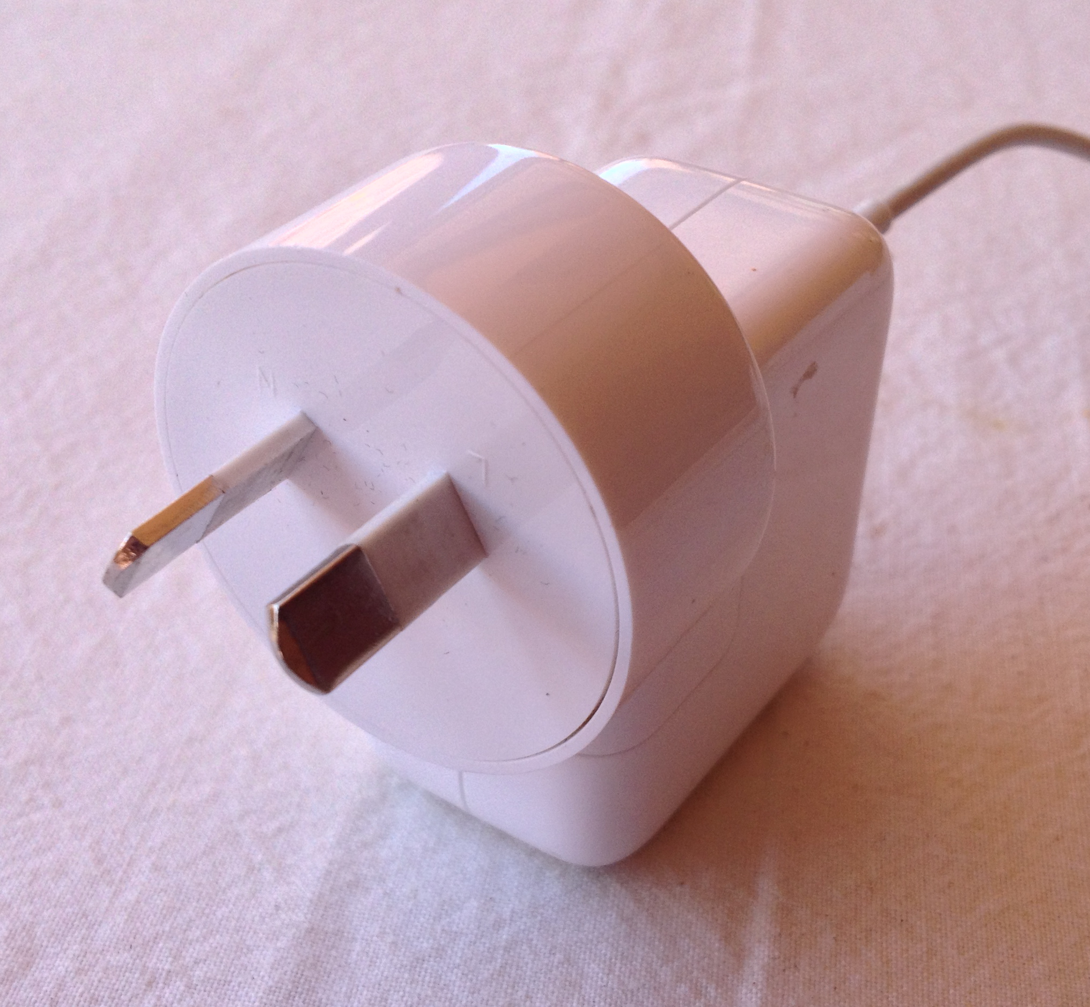

- Other appliances are connected to the mains with a cord and ‘2 pin’ plug. Why is it considered safe to use a ‘2 pin’ plug instead of a ‘3 pin’ plug for these appliances?
(2 marks)

Question 11 (3 marks)

In testing how a vehicle behaves in a head-on collision, a 4WD vehicle with a mass of 2500 kg, is driven at 18.0 m s⁻¹ and crashed into a steel and concrete barrier. The front of the car is extensively damaged but the passenger compartment is relatively undamaged.

- Apply your understanding of change of momentum to explain how the design of the
front of the car prevents the passenger section of the car from becoming too badly damaged. (1 mark)

- If the final speed of the 4WD, after the collision is 0.0 m s⁻¹, calculate its change in
momentum. (2 marks)

Question 12 (4 marks)

A researcher, while carrying out a geological survey, measures the amount of the isotope potassium - 40, (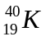) in a rock sample. She finds it contains one eighth of the expected amount of this isotope that would be present in a newly formed rock.
The half-life of is 1.28 x 10⁹ years.

- Calculate the age of the rock. (2 marks)

- Explain why it may be difficult to measure the half-life of in the laboratory. (2 marks)

Question 13 (8 marks)

The radioisotope iodine -131 is used in medicine to treat over-active thyroid glands. It decays into an isotope of xenon (Xe) by beta emission with a half life of 8.1 days. Xenon then emits a gamma ray.

- Write the two equations that represent these decays.

Equation 1 _________________________________________ (2 marks)

Equation 2 _________________________________________ (2 marks)

(b) In terms of half life explain why iodine is useful in this application. (2 marks)

(c) A laboratory technician who was handling various radioisotopes in the laboratory was
worried about her health because of exposure to radiation. She knows she is
receiving an absorbed dose of 0.008 mGy from alpha and 0.012 mGy from gamma
each day.

Calculate her dose equivalent over the past 25 days. (2 marks)

Question 14 (4 marks)

A year 11 student goes for a midday swim in winter and this causes her normal body temperature to fall by 2.0 ºC. She comes out of the water and stands with her back to the Sun to try and get warm. If the solar radiation reaching her is 900.0 W m⁻² and her average body specific heat is 3.50 kJ kg⁻¹ K⁻¹, ESTIMATE how long she needs to stand in the sun until her body temperature becomes normal again.

Question 15 (4 marks)

In the context of heat transfer, explain how conduction and convection differ from radiation using the kinetic theory of matter.

Question 16 (6 marks)

A ball is thrown vertically upwards from the top of a 58.0 m tall building. The ball has an initial speed of 15.0 m s⁻¹. (For the following questions assume negligible air resistance).

(a) Calculate the time for the ball to hit the ground. (4 marks)

(b) Calculate the ball’s speed on impact with the ground. (2 marks)

END OF SECTION 1

Section 2: Problem Solving

Marks allotted: 80 marks out of a total of 160 (50%)

This section contains 8 questions. Suggested working time 90 minutes

Answer the questions in the spaces provided.

Question 17 (13 marks)
Calculate the voltages V1 to V6 and currents A1 to A6 and the total resistance of the circuit below. Show your working under the diagram but write your answers in the table. (Exclude the internal resistance of the meters and the power supply).
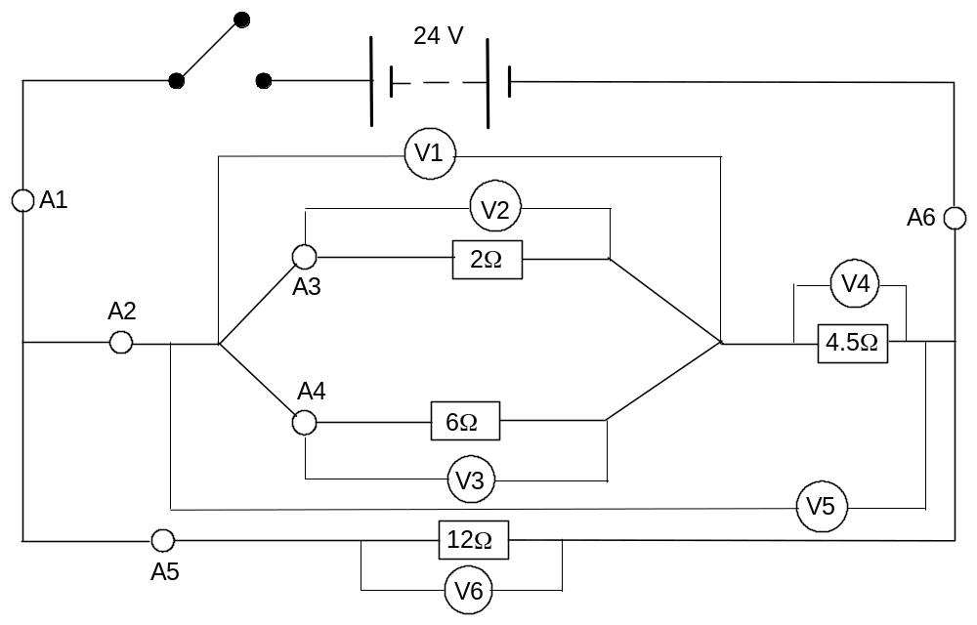

 | Voltage |  |  | Current
V1 |  |  | A1
V2 |  |  | A2
V3 |  |  | A3
V4 |  |  | A4
V5 |  |  | A5
V6 |  |  | A6

Total resistance

Question 18 (12 marks)

A 50.0 kg student undertakes a science project to show the relationships between force, vertical velocity and vertical acceleration. She enters a lift in a high rise building in the city with a set of bathroom scales. She stands on the scales and observes that the scale reading is 490 N when the lift is stationary.

(a) Her next reading is taken when the lift is moving. The reading is 450 N.

(i) Is the lift moving up or down? (2 marks)

Answer ______________________________________________

(ii) Is the lift accelerating up, accelerating down or moving at constant velocity? (1 mark)

Answer ______________________________________________

(b) Her second reading is taken when the lift is also moving. The reading is 540 N.

(i) Is the lift moving up or down? (2 marks)

Answer _______________________________________________

(ii) Is the lift accelerating up, accelerating down or moving at constant velocity? (1 mark)

Answer ________________________________________________

(c) The third reading is taken when the lift is also moving. The reading is 490 N.

(i) Is the lift moving up or down? (2 marks)

Answer _________________________________________________

(ii) Is the lift accelerating up, accelerating down or moving at constant
velocity? (1 mark)

Answer _________________________________________________

(d) A fourth reading of 400 N is observed by the student when the lift is moving.

Calculate the acceleration of the lift during this observation. (3 marks)

Question 19 (14 marks)

A typical nuclear reaction, which takes place in a nuclear reactor, is the fission of U-235 by a neutron to produce Xe-140 and Sr-94 as products, with the release of 2 neutrons and a large quantity of energy.

Data: mass of Xe -140 = 139.90544 u
mass of Sr-94 = 93.906378 u
mass of U-235 = 235.04392 u
mass of neutron = 1.008665 u

(a) Write a nuclear equation to represent this fission reaction (2 marks)

(b) How much energy (in joules) is released by the fission of ONE U-235 nucleus? (6 marks)

(c) The power consumption for Perth is 5.0 x 10¹⁸ J per month. If that was to be supplied completely by nuclear fission, calculate the mass of U-235 required per month? (6 marks)

Question 20 (9 marks)

An experiment was conducted in which 200.0 g of ice at 0.00 ºC was placed into a glass jug. An electric heater with a constant power output of 300 W was used to heat the glass jug and the ice. The transfer of heat from the electric heater to the ice/water was 80% efficient.
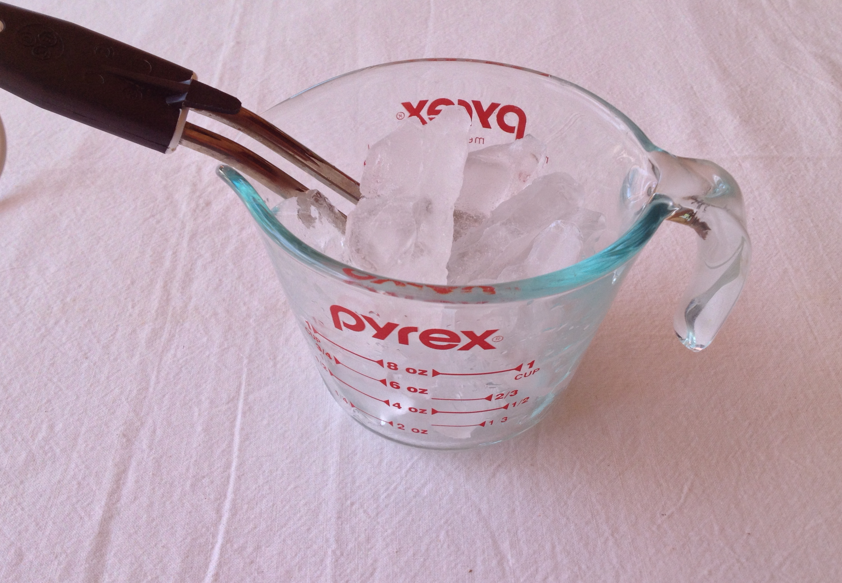

(a) Calculate the quantity of heat supplied by the electric
heater to melt the ice (1 mark)

(b) Calculate the time taken to melt the ice. (2 marks)

(c) Calculate the quantity of heat supplied by the electric heater to heat the water to its
boiling point. (2 marks)

(d) Calculate the total time taken to melt the ice and heat the water to its boiling point. (2 marks)

(e) On the graph grid below sketch a graph showing temperature (y axis) versus time
(x axis) for heating the ice and water to boiling point. (2 marks)



Question 21 (9 marks)

In a factory that manufactures plastic food wrap, the thickness of the plastic is monitored by a thickness recorder. The plastic passes between a beta particle source and a detector as shown in the diagram below. The table shows the readings on the detector (in counts per second) during one production run.

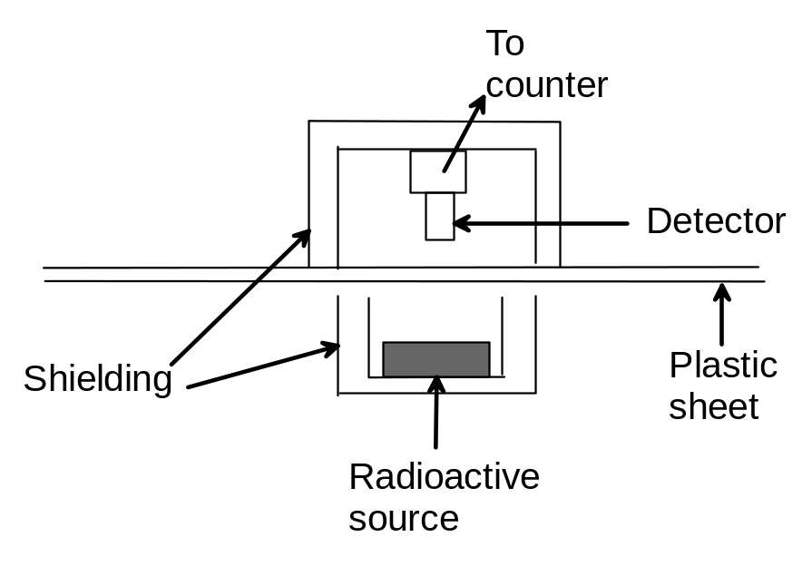
Time interval (min) | 0-2 | 2-4 | 4-6 | 6-8 | 8-10 | 10-12 | 12-14 | 14-16 | 16-18 | 18-20
Counts per second | 89 | 90 | 88 | 89 | 91 | 170 | 172 | 172 | 168 | 169

(a) State a probable cause for the reading during the sixth interval to be so different from
the fifth interval? (2 marks)

(b) From what material should the safety housing be made to offer MINIMUM necessary protection for workers working near the source? Explain your answer. (2 marks)

The radioactive decay curve for the beta particle source that was used in the thickness detector is shown below.

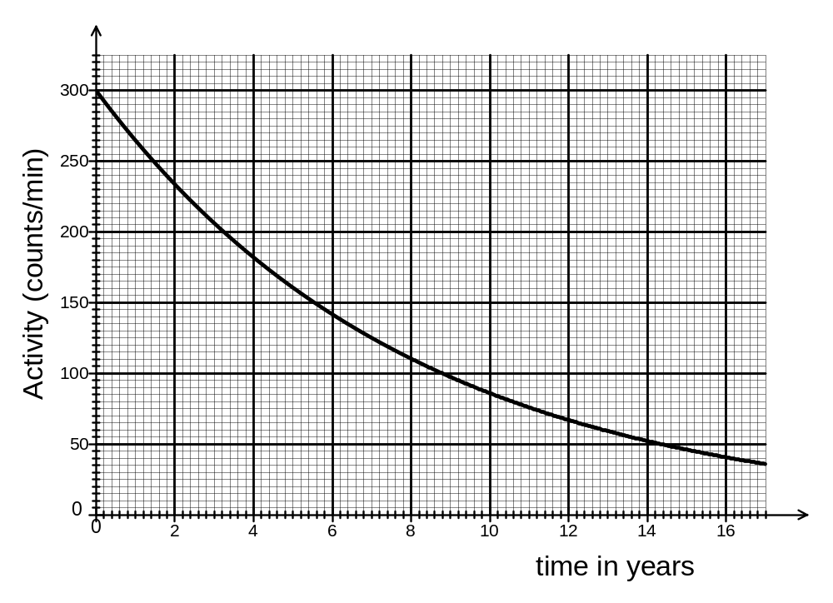
(c) Use the graph to calculate the half life of the source. Show construction lines clearly on the graph. (3 marks)

(d) Would this source be suitable to use in the thickness detector? Explain your answer. (2 marks)

Question 22 (8 marks)


A 2.50 kg remote controlled car accelerates uniformly from rest to a speed of 4.50 m s⁻¹ in 3.50 s, then travels at that speed for the next 3.00 s before decelerating to come to rest in a further 2.50 s.

(a) On the graph grid below, represent the
speed versus time of the car. Label the
axes and include scales and units for speed
and time. (2 marks)

(b) Use the graph to calculate the acceleration of the car during the first 3.5 s. (1 mark)

(c) Calculate the force required to accelerate the car from rest. (1 mark)

(d) Calculate the gain in the car’s kinetic energy during the first 3.5 s (2 marks)

(e) Calculate the power of the car’s motor when it is travelling at constant speed.
(2 marks)

Question 23 (8 marks)

(a) 20.0 g of ice at -15.0 ºC is placed in 85.0 g of water at 40.0 ºC in a 50.0 g copper
calorimeter and allowed to come to thermal equilibrium. Calculate the final
temperature of the water. (5 marks)

(The specific heat capacity of copper is 3.87 x 10² J kg⁻¹ K⁻¹)
(The specific heat capacity of aluminium is 9.10 x 10² J kg⁻¹ K⁻¹)

- If the calorimeter had been made of aluminium instead of copper, would you expect
the final temperature of the water to be higher, lower or unchanged from that
calculated in part (a)?

Answer ____________________________________________________ (1 mark)

(c) Explain your answer to part (b). No calculations are required but reference to relevant data is expected. (2 marks)

Question 24 (7 marks)

An electrical circuit was set up as shown below. There are two meters, a 9.0 V cell, four resistors and a switch.
The total resistance, R_{t} of the circuit is 16.0 Ω.

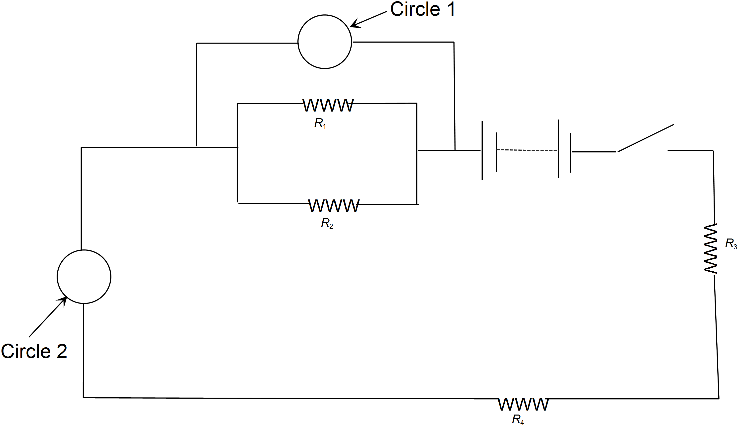
(a) The circles in the circuit indicate where the meters are located. In circle 1 clearly
write the letter ‘A’ for ammeter or ‘V’ for voltmeter to indicate which meter would be
correctly placed there. Explain why you have chosen to label the meter that way. (1 mark)

(b) In circle 2 clearly write the letter ‘A’ for ammeter or ‘V’ for voltmeter to indicate
which meter would be correctly placed there. Explain why you have chosen to label
the meter that way. (1 mark)

(c) R₂ has a resistance of 8.0 Ω, R₄ has a resistance of 2.0 Ω and the total resistance of R₁ and R₂ is 6.0 Ω. Calculate the resistance of R_{1.} (1 mark)

(d) On the diagram use an arrow to indicate the direction of electron drift in this circuit.
(1 mark)

(e) Calculate the resistance of R₃. (1 mark)

(f) Calculate the current flowing through resistor R₃. (2 marks)

END OF SECTION 2

Section 3: Comprehension
(Marks allocated: 16 marks out of 160 (10%). Suggested working time 20 minutes.

This section has one (1) question. You must answer this question. Write your answer in the spaces provided.
When estimating numerical answers, show your working or reasoning clearly. Include appropriate units where appropriate.
You are reminded of the need for clear and concise presentation of answers. Diagrams (sketches), equations and /or numerical results should be included as appropriate.

Question 25
SMOKE DETECTORS

Householders Ignore Fire Brigade Advice
on Smoke Detectors

Thirty-two people died and 567 were injured in fires in West Yorkshire last year.

However, only 7% of householders in Yorkshire and Humberside have followed fire brigade advice to fit smoke detectors, which give an early warning of fire and allow time to escape.

A recent Government sponsored survey shows the region joint bottom of all areas in England and Wales. Said Assistant Chief Officer Peter Kneale: "Despite our efforts for the past two years, the area is still well below the national average of 10% in its provision of smoke detectors.”

"We are disappointed to read the statistics when we look back at the efforts we have made to sell the message that smoke detectors save lives."

The survey also shows that pensioners are the most poorly provided for, with only 5% having a smoke detector, despite being one of the groups most at risk.
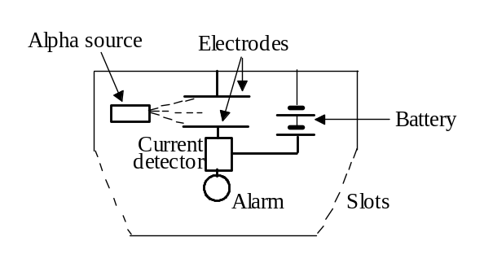

The diagram opposite shows the construction of one kind of smoke detector.

The weak radioactive source has a long half life and gives out alpha particles. (Americium-241 is often used.) The alpha particles ionise air molecules in the detector. The ions are attracted to one or other of the electrodes, so a small current flows.

If smoke enters the detector, fewer ions are produced so less current flows. This decrease in current is detected electronically and the alarm is sounded.

Americium-241 has a half life of 432 years. It is used in preference to other radioactive sources
that produce mainly, beta and gamma radiation. The radiation emitted by americium has high
ionizing capabilities and low penetration power. Only about one percent of the emitted radioactive energy of Americium-241 is gamma radiation.

The amount of elemental Americium-241 is small enough to be exempt from the regulations
applied to larger sources. A typical smoke detector contains about 37 kBq of radioactive element
Americium-241 corresponding to about 0.3 µg of the isotope. This provides sufficient ion current to detect smoke, while producing a very low level of radiation outside the device.

The americium-241 in ionizing smoke detectors poses a potential environmental hazard. Disposal regulations and recommendations for smoke detectors vary from country to country.

Questions
(a) Explain what happens to air molecules when they become 'ionised'. (2 marks)

(b) Write a likely nuclear equation for the decay of americium-241 as used in a
smoke detector. (2 marks)

(c) Suggest a reason why fewer ions are produced if smoke enters the detector.
(2 marks)

(d) Explain why a radioactive source that gives out alpha particles is used, rather than
one that gives out beta or gamma radiation? (3 marks)

(e) Americium – 241 emits dangerous gamma radiation. Why is this not considered a hazard in the case of smoke detectors? (1 mark)

(f) What is meant by the 'half life' of a radioactive substance? (2 marks)

(g) Explain why the radioactive source used in the detector should have a long half life.
(2 marks)

(h) Some householders might be worried about the presence of a radioactive source in
the detector. What could you say to convince such a person that it is safe?
(2 marks)

END OF QUESTIONS

